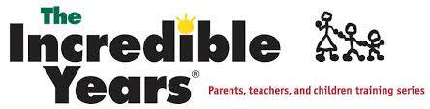

Incredible Years® is a research based positive Parenting Course which has shown to be effective for helping parents manage emotional and behavioural difficulties. A recent research study showed that there were huge improvements in behaviour for 70% of children.*
Incredible Years® helps parents to build a positive and calm home environment. All children can experience emotional and behavioral difficulties which can put huge stress on families. If you are having difficulty managing routines, mealtimes, getting to school, bad behaviour - then this might be the course for you.
The Incredible Years® BASIC Parent course is a 14 week group course. The course runs once a week for 14 weeks and each weekly session last 2hrs. This course is designed for parents of children aged 3-10 years and covers a range of topics including: play, routines, behavior issues, time-out for bad behavior, problem solving, limit-setting, consequences, social and academic skills among others.
The Incredible Years® Parenting programme is a practical course designed to help parents strengthen their parenting skills and reduce behaviour issues. Course handouts are provided each week.

This Free programme will begin on Wednesday the 28th February 2018 from 10-12pm in Turners Cross Community Centre, Church view, Turners Cross, Cork.

Please contact Sandra O’Meara, Rapid Coordinator, Cork City Council, email: sandra_omeara@corkcity.ie or Linda Mc Kernan, Community Development Worker, Cork City Partnership, email: lmckernan@partnershipcork.ie to register
Please contact Linda on 087 1962025 if you require any further information

